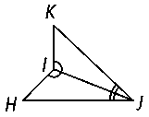**Given: ∠***HIJ* ≅ ∠*KI*

*∠IJH* ≅ ∠*IJK*

**Prove: Δ***HIJ* ≅ **Δ***KIJ*

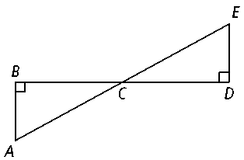**Given:** ∠*B* and ∠*D* are right angles.

*EA* bisects *BD*

**Prove: Δ***ABC* ≅ **Δ***EDC*

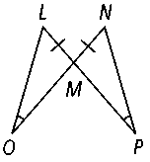**Given:** ∠*LOM* ≅ ∠*NPM, LM* ≅ *NM*

**Prove: Δ***LOM* ≅ **Δ***NPM*

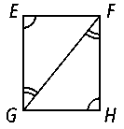**Given:** ∠*E* ≅ ∠*H*

∠*HFG* ≅ ∠*EGF*

**Prove: Δ***EGF* ≅ **Δ***HFG*

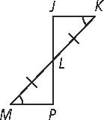

**Given:** ∠*K* ≅ ∠*M*

** ≅ 

**Prove: Δ***JKL* ≅ **Δ***PML*

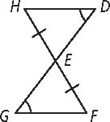

**Given:** ∠*D* ≅ ∠*G*

** ≅ 

**Prove: Δ***EFG* ≅ **Δ***EHD*

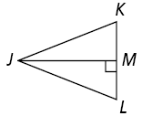

**Given: **bisects ∠*J*.

* * 

**Prove: Δ***JMK* ≅ **Δ***JML*

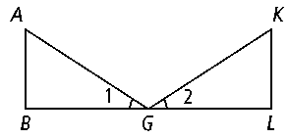

**Given:** ∠1 ≅ ∠2,  *, *  *, * ≅ 

**Prove: Δ***ABG* ≅ **Δ***KLG*

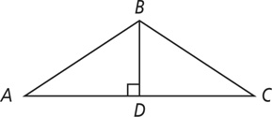**Given:**  ** bisects ∠*ABC*

**Prove:** ∆*ABD* ≅ ∆*CBD*

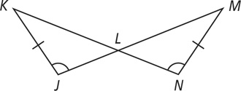**Given: ∠***KJL* ≅ ∠*MNL*

**Prove: ∆***JKL* ≅ ∆*NML*

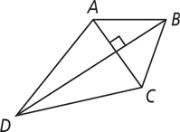**Given:** ** is the angle bisector of ∠*ABC* and ∠*ADC.*

**Prove:** ∆*ABD* ≅ ∆*CBD*

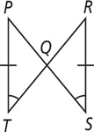

**Given:** *∠PTR* ≅ *∠RSP*

**Prove:** ∆*PQT* ≅ ∆*RQS*